New error-unresolved

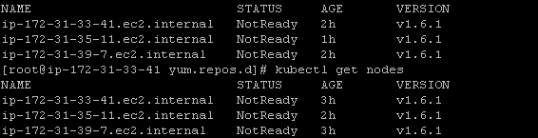

Showing as network issues